**Cosmetic Store Management**

**College Name**: Sri sarathi institute of engineering and technology

**Team Leader**:Cheepi Naga Ramya

[chnagaramyaramya@gmail.com](mailto:chnagaramyaramya@gmail.com)

Team Member:Manikala Madhavi

[Madhavimanikala060@gmail.com](mailto:Madhavimanikala060@gmail.com)

Project overview :

cosmetic system management (CSM) involves overseeing the day-to-day operations of a cosmetics store, including buying and selling, sales and marketing, and staff management and Informing customers about new product and special events

Objectives :

Customer retention : Address customer risks and concerns to retain customers

Customer experience : Enhance the customer experience and streamline the customer journey

Product adoption : Ensure customer adopt the product or services

Bussiness outcomes : Deliver position business outcomes

Trusted advisor relationship : Establish trusted advisor relationship with customers Account expansion : Identity opportunities to expand accounts

Salesforce key features and concepts utilized :

* Creating a developer org.
* Creating custom objects.
* Tabs.
* Lighting app(Workforce administration solution).
* Fields and relationships.
* Owd settings.
* User adoption.
* Import data.
* Profiles.
* Roles.
* Users.
* Page layouts.
* Chatters group.
* Record types.
* Permission sets.
* Reports and Dashboards.

Detailed steps to solution design :

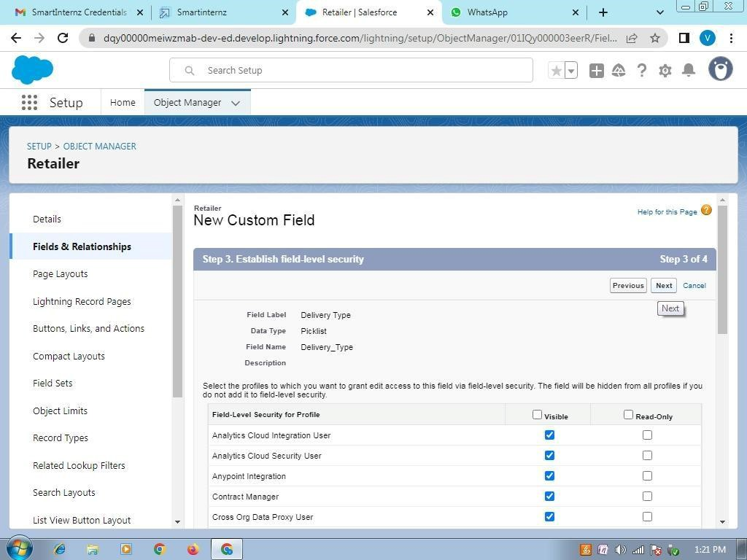

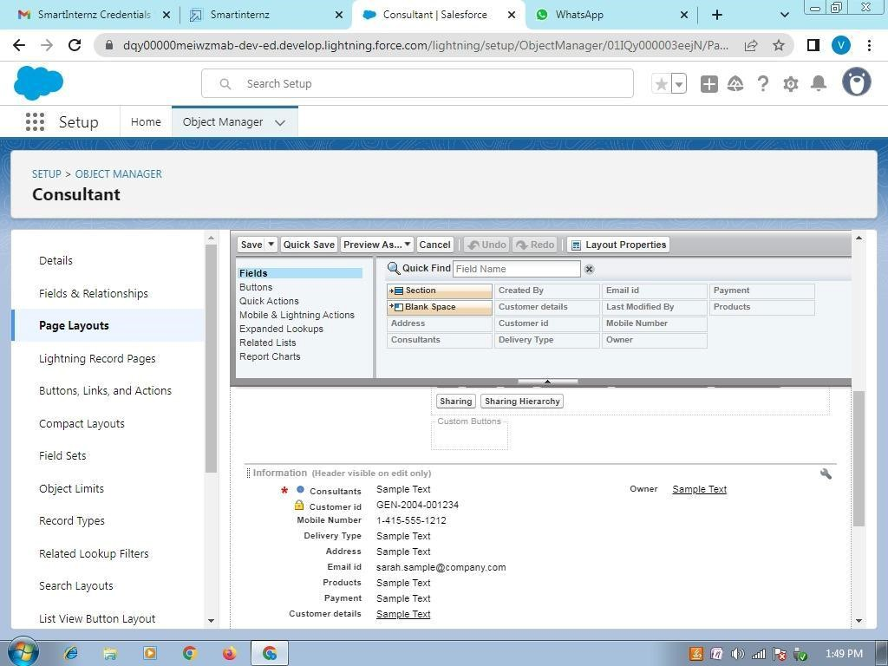

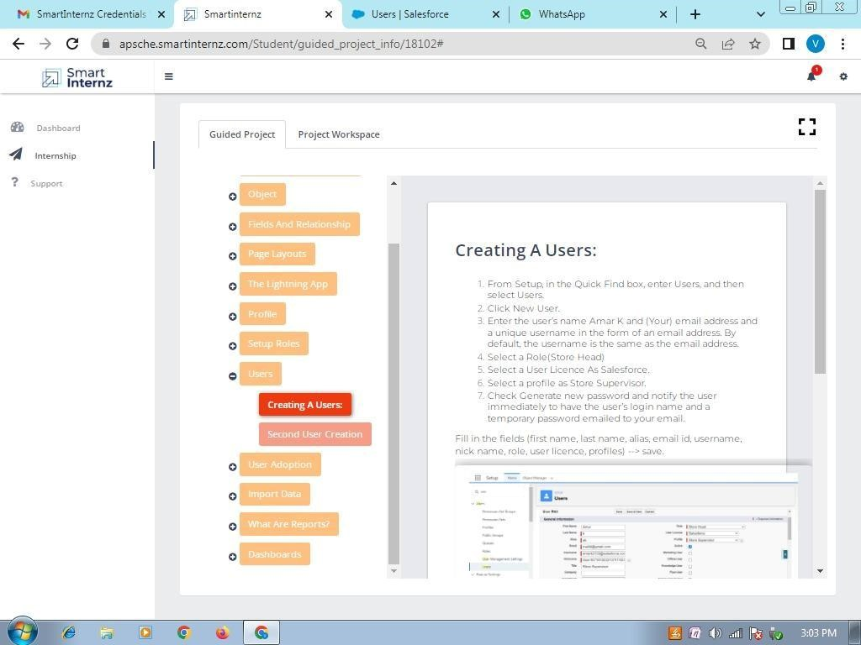

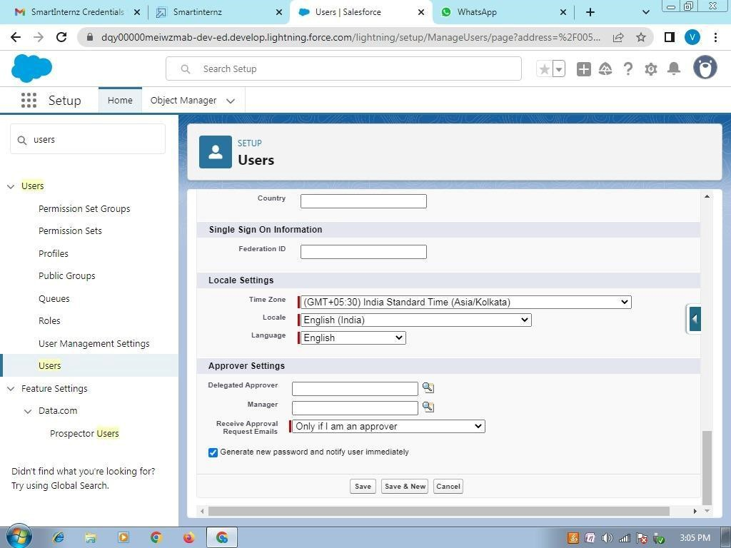

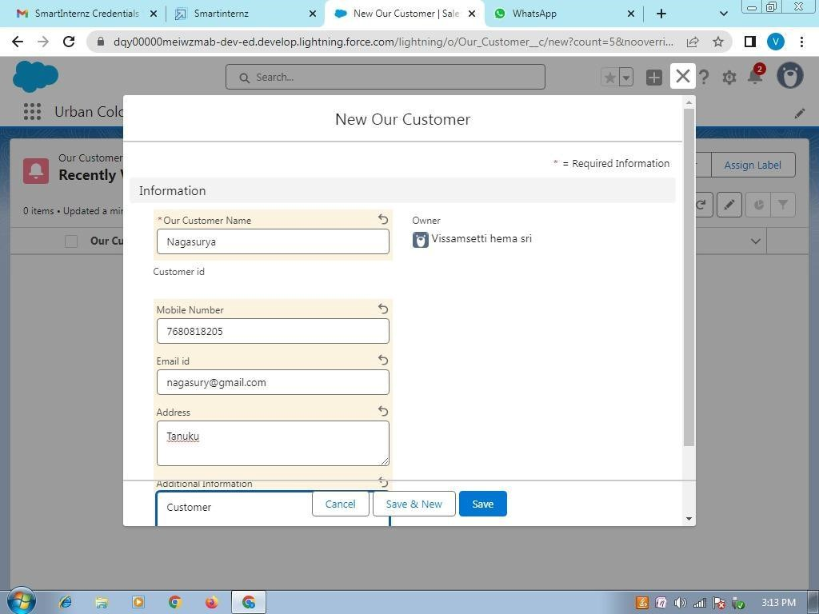

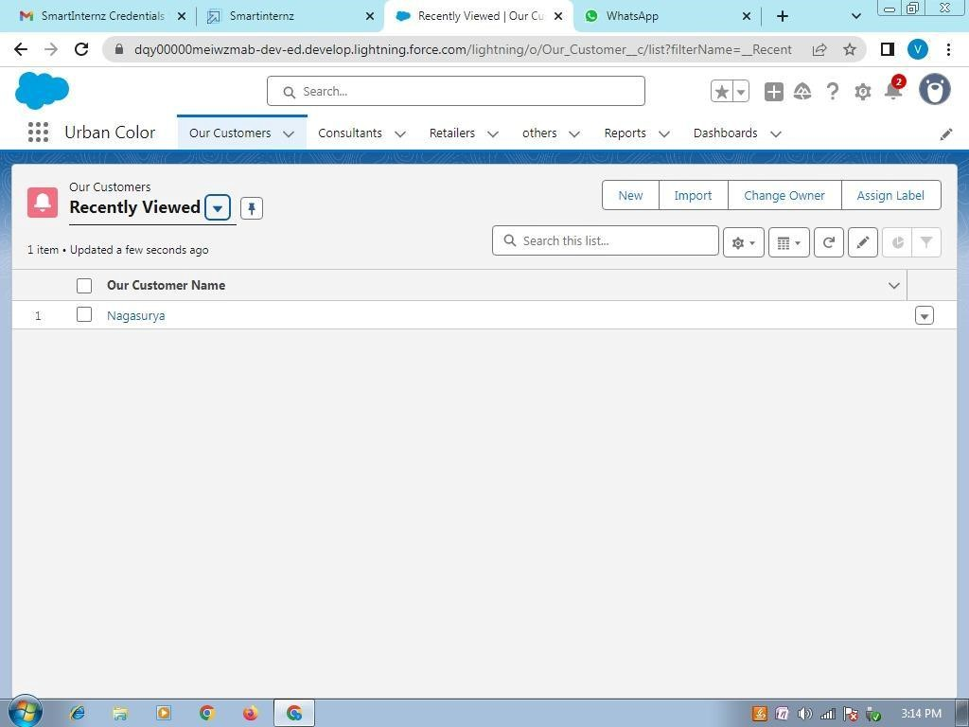

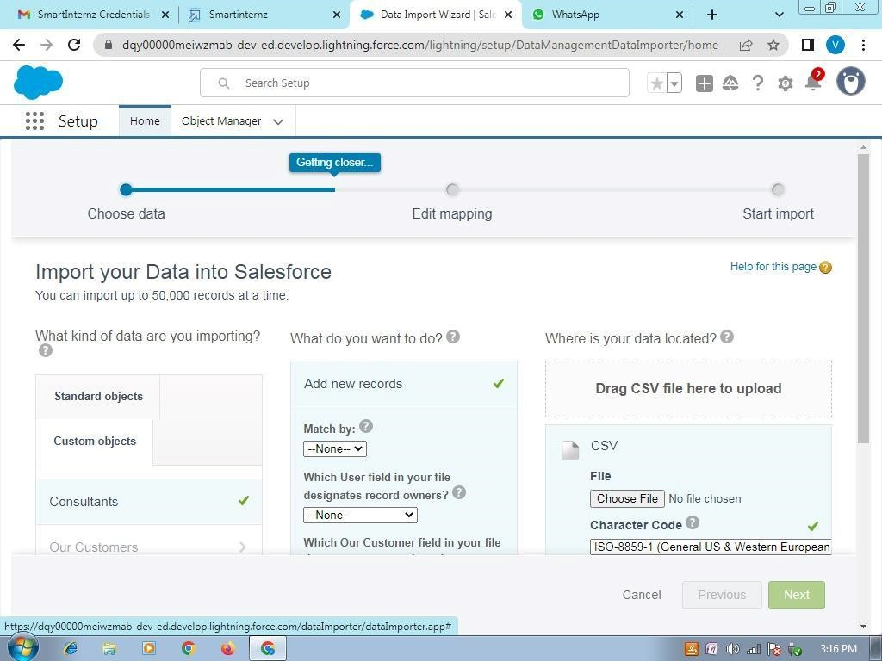

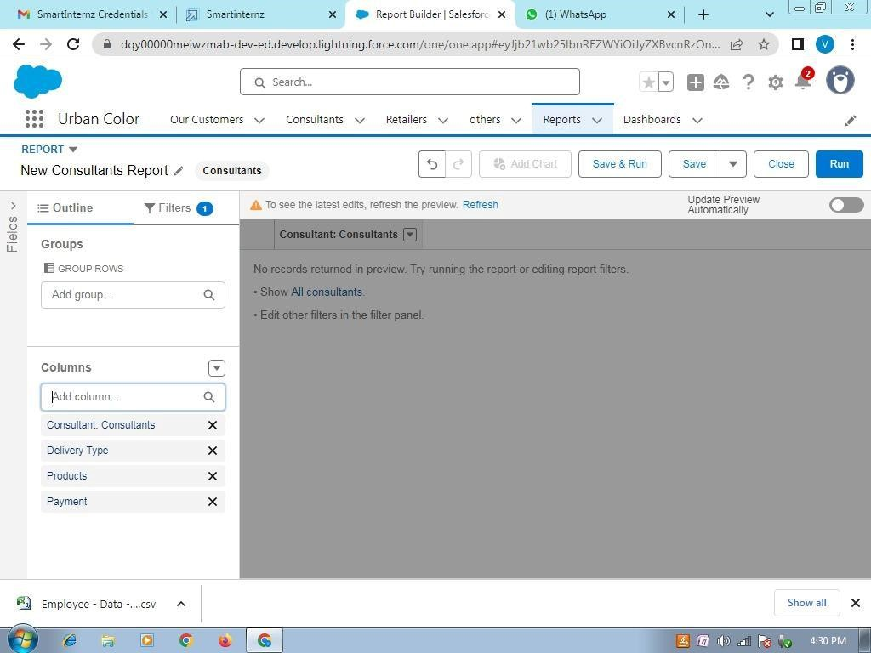

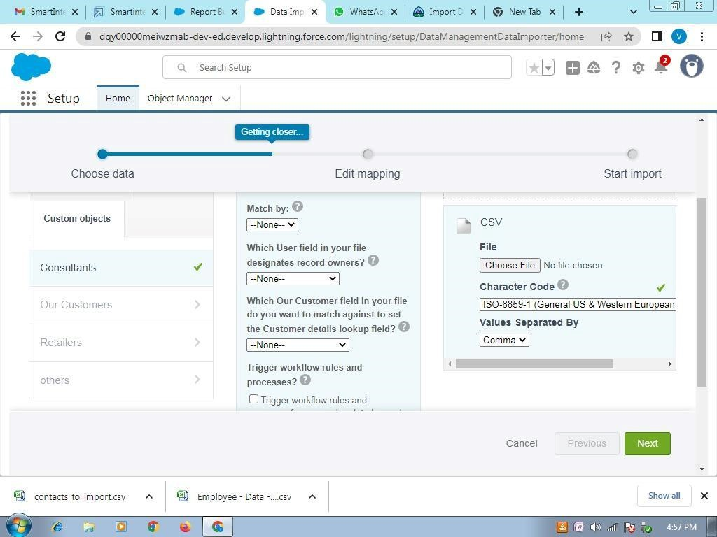

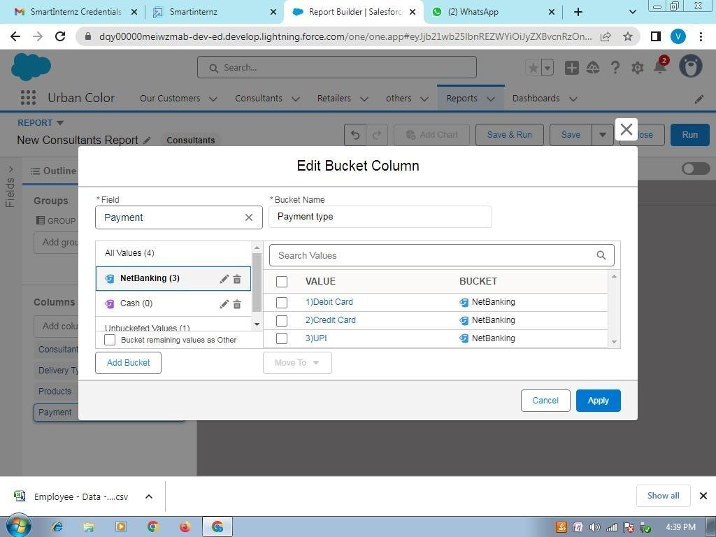

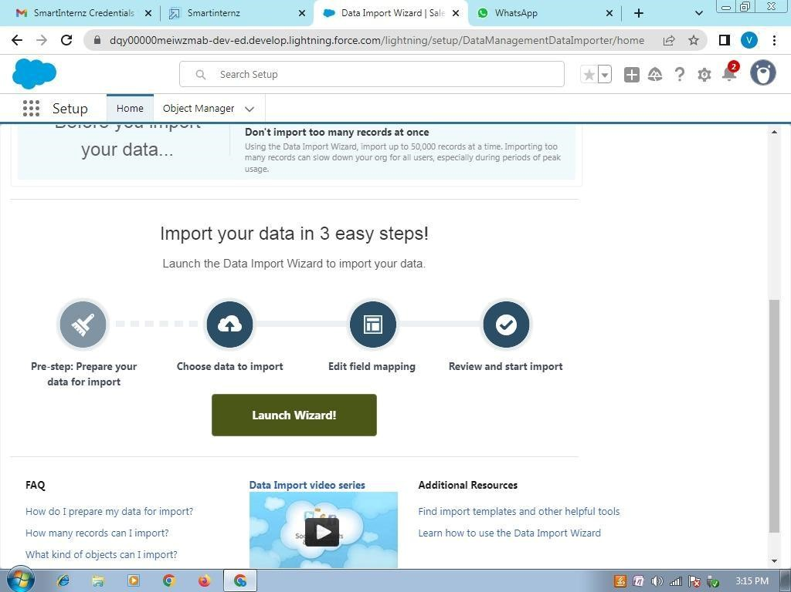

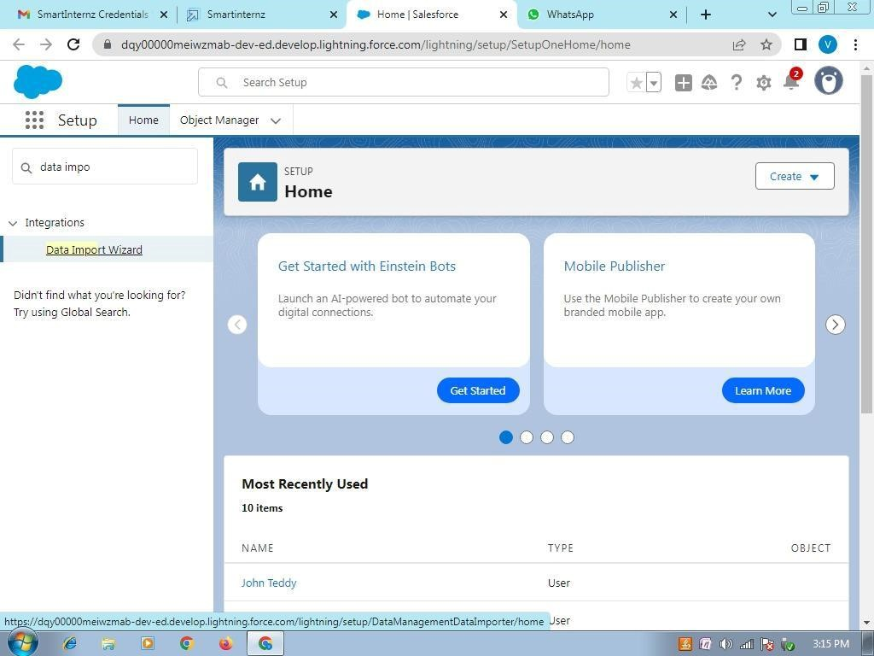

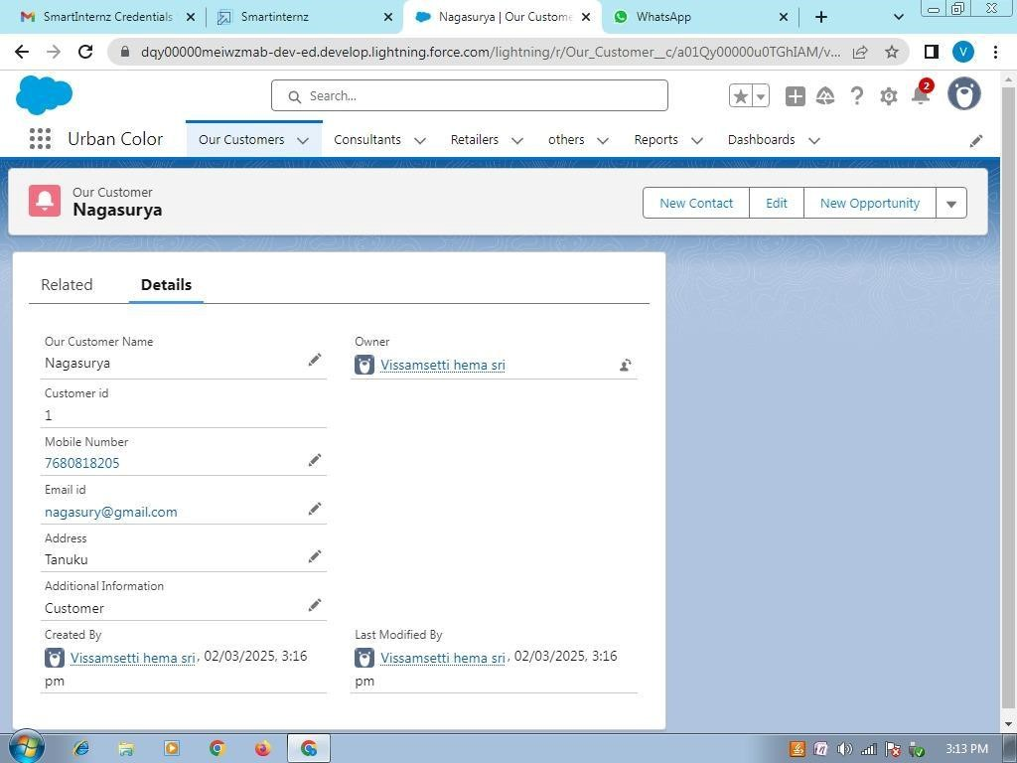

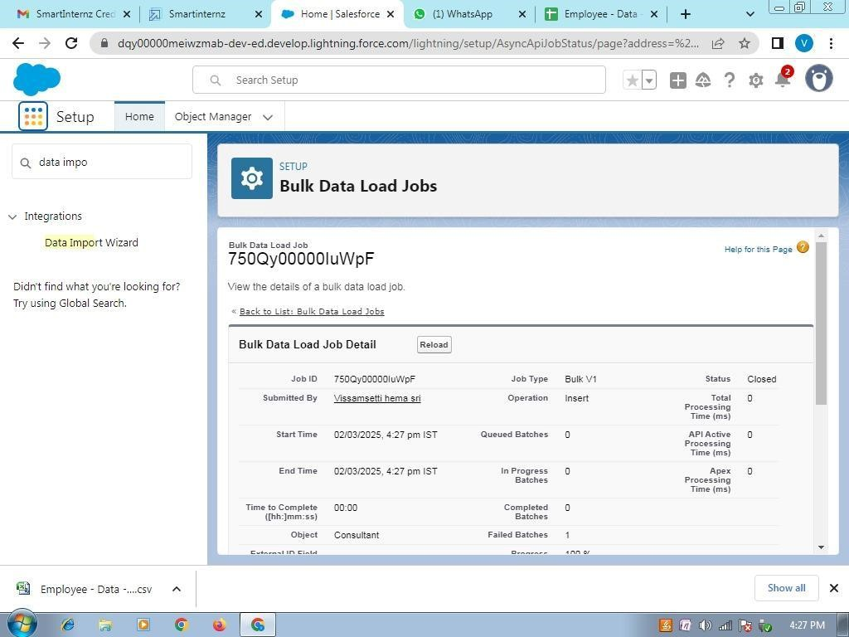

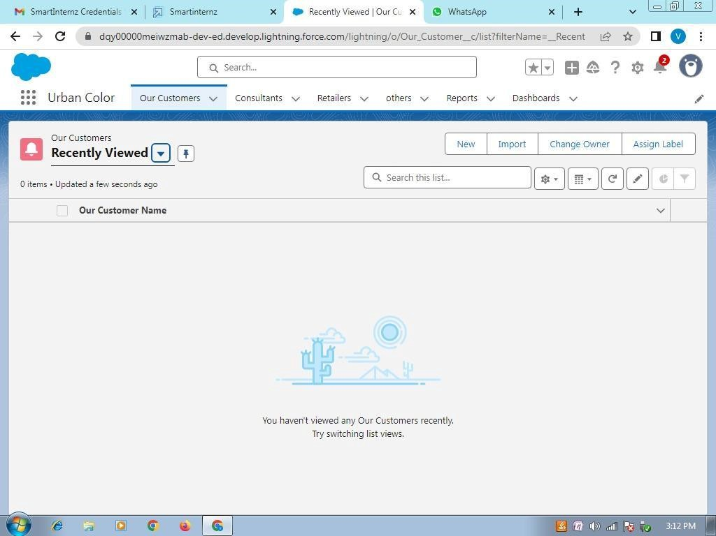

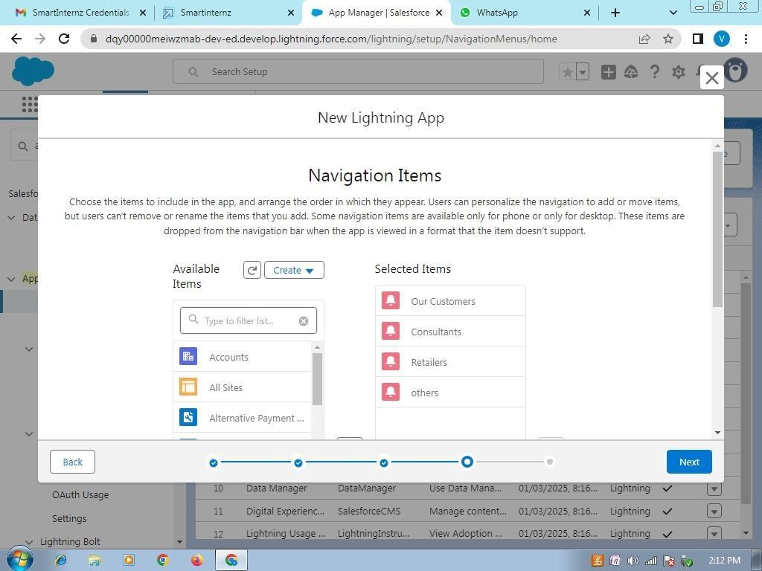

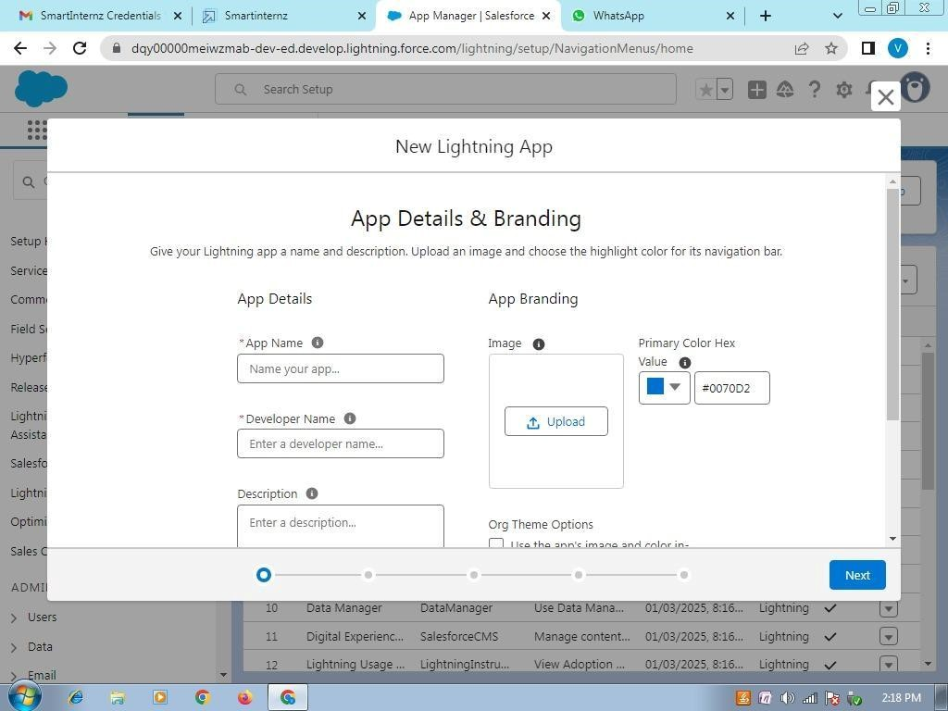

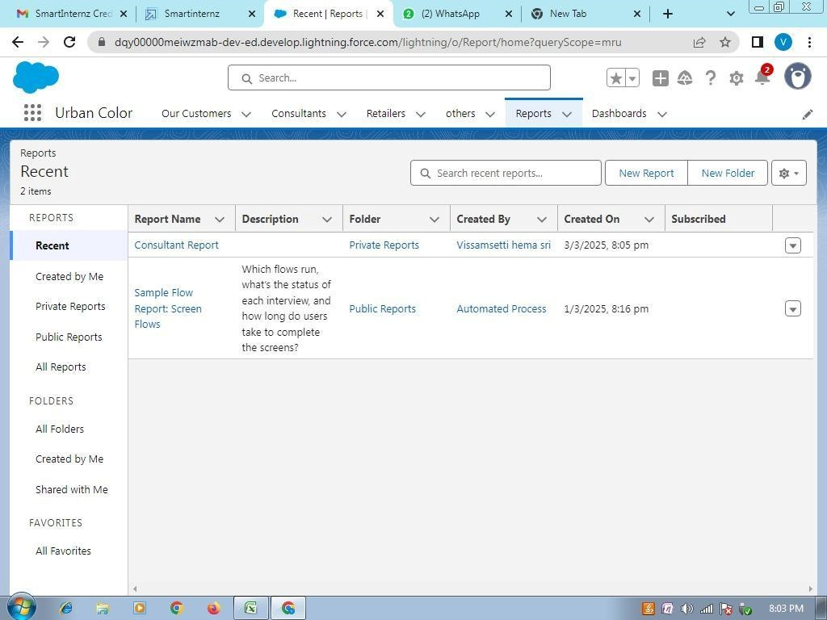

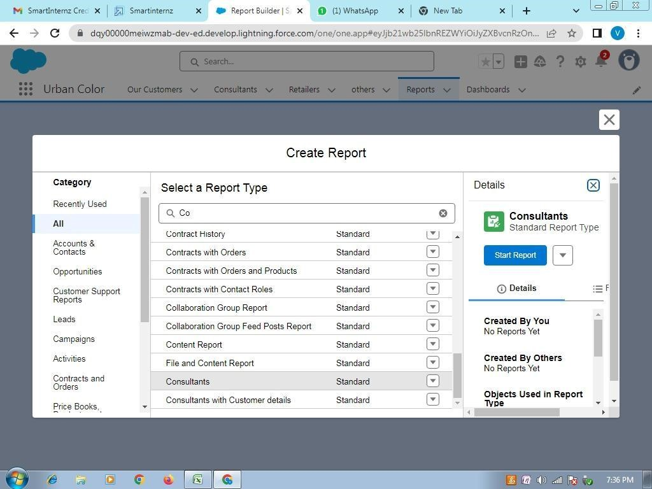

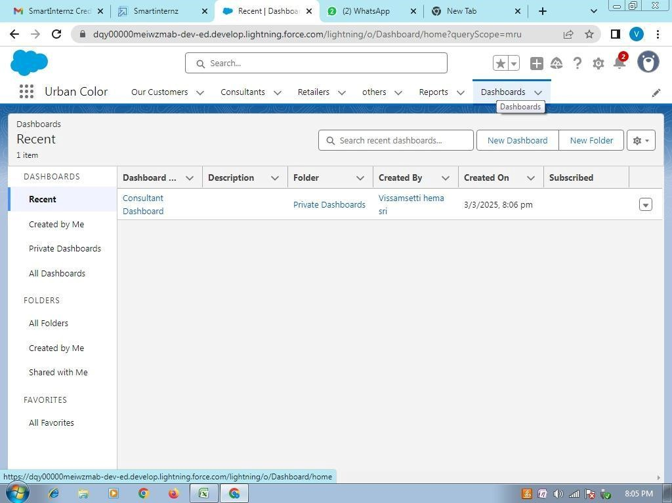

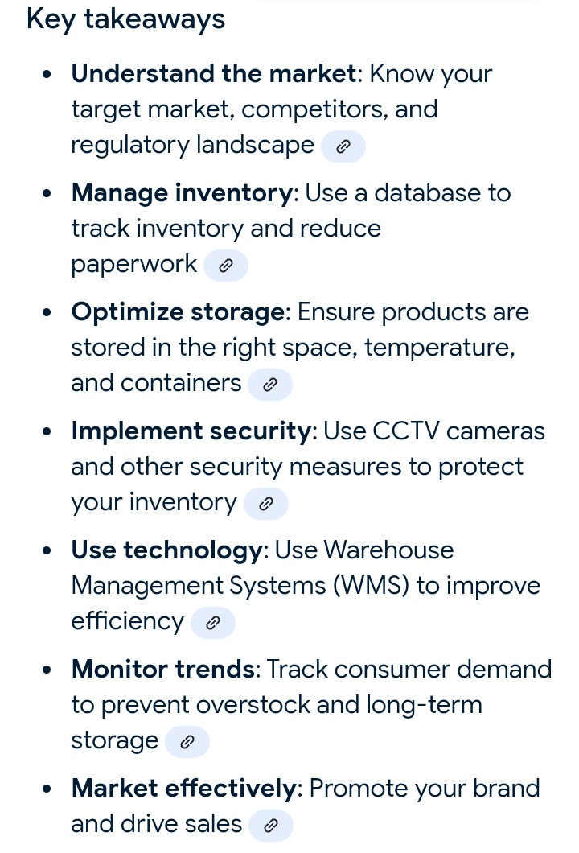

**Conclusion** :

In my point of view,the implementation of Salesforce is a complex process

that requires careful planning, execution, and testing. Throughout this project, we have outlined the key steps involved in implementing Salesforce, including requirements gathering, solution design, testing and validation, and deployment.

We have also identified key scenarios addressed by Salesforce in the implementation process, including sales, marketing, service, commerce, analytics, and integration scenarios.

By following the steps outlined in this project and addressing the key scenarios, organizations can ensure a successful Salesforce implementation that meets their business needs and drives user adoption.